**Title:** eTransportation Management System

**Expected Finish Date:** 2022-10-25

**Author:** [Muhammad Hilmi Fawwaz](mailto:18120050@std.stei.itb.ac.id)

**Related components:** [What is Transport Management System](https://www.altexsoft.com/blog/transportation-management-system/)

**External Link:** -

**Approvers:** Efishery Academy Mentors

|  |  |  |  |
| --- | --- | --- | --- |
| **Name** | **Yes|NotYet** | **Approved Date** | **Remarks** |
| [Puja](mailto:sjarif.hd@efishery.com) [Pramudya](https://id.linkedin.com/in/pujapramudya) | Not Yet | <YYYY-MM-DD> |  |
|  |  |  |  |

**Others Reviewer(s):** -

**Start Date:** 2022-10-25

## Summary

Manajemen logistik untuk perusahaan logistik. eTMS ini akan digunakan untuk mengontrol status dispatching melalui API yang dibuat.

## Problem & Motivation

Sebuah perusahaan logistik memerlukan pemantauan status keberjalanan bisnis secara digital. Proses logistik yang akan dilakukan adalah: Assignment dari dispatcher menuju kurir/sopir, sopir menerima assignment untuk mengantarkan barang sampai ke tujuan, dan sopir mengabarkan status ketersampaian. Dengan platform digital, dapat dihasilkan produk kontrol status yang lebih transparan dan mudah diakses. Platform ini akan memantau keberlangsungan logistik pada transportasi Truk.

## Detailed design

### Database Design

**Database eTMS_main**

|  |  |  |  |
| --- | --- | --- | --- |
| **Name** | **Type** | **Required** | **Description** |
| id | serial | yes | auto increment id |
| Truck_id | int | yes | Which truck brings the batch |
| Driver_id | Int | Yes | Which driver brings the batch |
| Batch | Int | Yes | Which batch this trucks in |
| description | varchar | yes | Overall description of the logistic |
| time_dispatch | timestamptz | yes | Time of the dispatch happens |
| Time_arrive | timestamptz | yes | Time of the arrival happens |
| route | varchar | no | Trucks Route |
| position | int | yes | Trucks Current Position |

**Database Driver**

|  |  |  |  |
| --- | --- | --- | --- |
| **Name** | **Type** | **Required** | **Description** |
| Driver_id | Int | Yes | Which driver brings the batch |
| name | varchar | yes | Driver’s name |

### API Contract

|  |
| --- |
| Description : get active drivers URL : /drivers  Query Param   1. Banner Type    1. Example URL = /drivers   Headers : without auth  Response :  200 Success {  "message": "successfully found drivers",   "success": true,  "data": [{  "truck_id": "1",  "driver_id": "1",  "description": "Truck full of nuts",  "route": {…},  }] }  if drivers not found  Response :  200 Success {  "message": "failed fetch drivers data"  "success": true,  "data": [] } |

### 

### 

### Whimsical

Application Name : eTransport Management System

Flow:

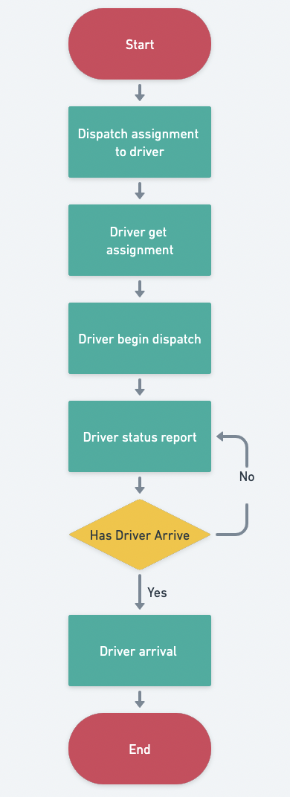

## Dependencies

* Database System
* Form system

## Milestone/Deployment Strategy

**Adoption and Migration**

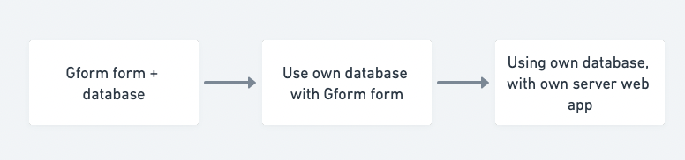

## Drawbacks/Risks

* Server down
* Server breached

## Alternatives

* Using other TMS system. Such as Kargo

## Unresolved/Future Possibilities

<listing sesuatu yang masih abu-abu dan ga jelas, perlu riset lanjut, kemungkinan ke depannya>

* Membuat TMS khusus ikan, udang, atau aquacultur lainnya.